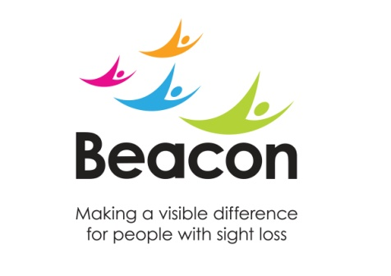 | Beacon  Conference Centre  How to find us:
 | Travelling by bus and train
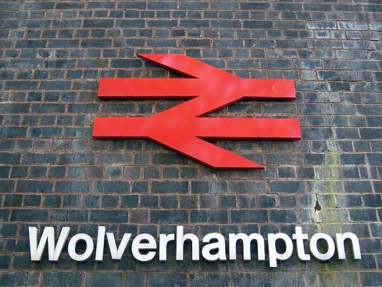 | From Wolverhampton train station:  Regular train services run to and from Wolverhampton daily.  (A taxi rank is located outside and the bus station is less than 2 minutes walk over the bridge).
From Wolverhampton tram station:

Regular Metro tram services run to and from Wolverhampton and Birmingham daily (a taxi rank is located nearby and the bus and train station are less than 5 minutes walk).

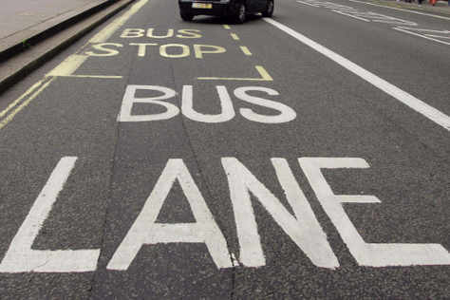 | From Wolverhampton bus station:  Bus No 1 runs every 7 - 8 minutes via Goldthorne Park  Bus No 27/27A runs every 30 – 60 minutes via Goldthorne Park
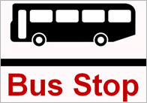 | From Dudley bus station:  Bus No 1 runs every 7 -8 minutes via Sedgley  Bus No 27/27A runs every 30 - 60 minutes via Gornal Wood and Sedgley
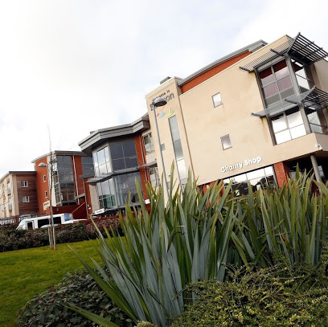 | Access  Beacon Centre is located on Wolverhampton Road East  (A459), just down from a Total petrol station.  From Wolverhampton it is just past ‘Dovedale Road ‘; from Sedgley / Dudley just past ‘The Northway ‘.  Reception is on the Ground floor, access via steps or a lift.
Beacon Centre for the Blind  Wolverhampton Road East  Wolverhampton  WV4 6AZ  T: 01902 880 111  F: 01902 886 795  E: enquiries@beaconvision.org  W: www.beaconvision.org  Registered Charity No 216092 | Parking  There is free parking in the car parks to the front or to the side of the building. The car parks can get busy so please allow sufficient time to find a space. There is street parking in surrounding streets if the car park is full.
Directions
Please refer to our website:
www.beaconvision/about-beacon for google map.

