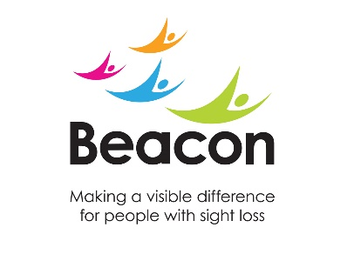

Beacon Blindfold Walk Terms and Conditions

- The Beacon Blindfold Walk is organised by the Beacon Centre registered charity number 216092 (England and Wales)

- By purchasing a ticket you agree to abide by the terms and conditions of the event and declare that you are fit to take part on July 7th 2018 and that the details provided on the entry forms are correct.

- If you are registering other people into this event you are accepting the terms and conditions on their behalf and are confirming that you have been given the authorisation to do so.

- You agree to abide by any instructions given to you by the organisers and marshals during the event.

- Entry fee is non-transferrable or non-refundable. This does not affect your statutory rights.

- Participants under the age 16 years must be accompanied by a parent or guardian, who will take full responsibility for them throughout the event.

- Under 16s must have their tickets purchased by a parent or guardian who has deemed them fit to take part and agreed to the terms and conditions on their behalf. A parental consent form will also need to be completed at the registration point.

- All under 16s taking part in the event must be accompanied by an adult during the whole of the event.

- All participants are responsible for ensuring that they will be able to guide their blindfolded partner safely during the event

- By agreeing to these terms and conditions you will receive a limited number of emails which will include the event information and updates.

- We abide by the data protection act and your information will be stored accordingly. It will not be passed onto a third party.

- All participants must carry their name, details of any health problems and an emergency contact number during the event which the organisers may use to contact someone if needed.

- If the event is cancelled or delayed due to unforeseen circumstances the organisers’ liability will cover the entry price you have paid to take part only.

- You agree that should the event be cancelled due to an event beyond the reasonable control of the organisers, including but not limited to: severe weather, terrorism, act of god, closure of the area by emergency services, medical advice, you will not be entitled to a refund of the entry free.

- The Race Organisers reserve the right to refuse an entrant attendance at, and/or participation in, the Event or any future Event. Any participant who is found in breach of these terms and conditions will be excluded from any future events organised by the Race Organisers.

- By taking part in the event you give permission for any photographs or film footage featuring yourself taken during the event to be used in any broadcast, advertising, promotion or other communication both now and in the future.

- By registering an under 16yr old as a participant, the parent or guardian confirms that they are happy for any footage or photographs taken which may feature the under 16 years old during their participation in the Event to be used in this way.

- All participants enter this Event entirely at their own risk and the Organisers shall not be liable for any injury or loss that might occur as a result of their participation other than as a result of the Organisers.

- The Organisers take all reasonable steps to minimise the risk of injury to participants during the Event, including undertaking a detailed risk assessment which aims to minimise or eliminate the risk to everyone taking part. However, by taking part in this Event, you acknowledge that there may
be conditions or circumstances beyond our control that can lead to unforeseen risks.

- By entering the Event, you accept all the conditions of entry and acknowledge that, to the extent permitted by law, the organisers and sponsors shall have no liability to me and team members for any injury, loss or damage, nor any consequential loss or damage suffered by me at or by reason of the Event.

- Any dogs brought to the Event must be kept on a lead at all times.

