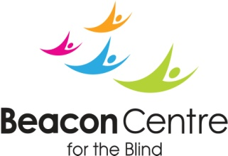
Black Country Talking News Volunteer

Responsible to : Kam Cheema – Communications Manager
Hours available: Wednesday A.M.
Purpose: Assisting staff to create a talking newspaper on a weekly basis for visually impaired clients.

Summary of duties
- To record audio transcriptions of newspapers for visually Impaired people
- Reading from a newspaper or other various articles/materials whilst being recorded, in a recording booth
- Editing of master copies of the talking newspaper (not essential)
- Emptying and sorting of postal wallets
- Copying and packing of newly recorded CD’s
- Conducting Interviews with people from various backgrounds.

The Role
- Clear and friendly recording voice
- Good communication skills and an outgoing and friendly approachable manner are essential, as are reliability and a commitment to confidentiality
- An opportunity to meet new people
- Ability/willingness to understand the issues faced by Individuals living with sight loss
- To be non-judgemental and have the ability to treat people with respect
- A DBS disclosure is required for this role

